Training Frequency, Weekly Volume, and Muscle and Strength Gains in Resistance Training Studies

Navaraj Thapa, Abdul Sheikh, Shishir Sharma, and Prashanna Shakya
King’s College, Westcliff University
Data 200
Professor Regmii
October 18, 2026

Training Frequency, Weekly Volume, and Muscle and Strength Gains in Resistance Training Studies
Most training advice comes down to two fundamental questions: How often should I train a muscle per week? How much volume should I accumulate during that week? Both of these parameters are incredibly simple to manipulate, which creates a topic of discussion that often goes over the edge of what the evidence would tell us. This study aims to investigate the possibilities (and shortcomings) of a well-honed statistical workflow as applied to a real, published dataset. It consists of open data from a meta-regression of resistance-training studies (Pelland et al., 2026). For each training group, it notes how many times muscle was trained, how many hard sets completed per week, and how much muscle size and strength increased. There is no usable protein variable, so volume (hard sets per muscle per week) will have to be used as the second predictor. Note that volume and frequency can often be conflated in practice, but for our purposes we should treat them as distinct.
The goal, is to test the interaction (independent or synergistic), between weekly volume and weekly training frequency for muscle size and strength, and the robustness of this estimate after performing assumptions and models testing on studies not included in the dataset. A problem arises early in the process: each row of the dataset, is the average of a published training group, representing some subjects instead of individuals, and showing association instead of causation.
Research Questions and Hypotheses
We asked four research questions. Each has a null and an alternative hypothesis, and we wrote them down before running any test (Table 1).
Table 1
Research Questions and Hypotheses
 | Research question | Null hypothesis (H0) | Alternative (H1)
RQ1 | Is weekly training frequency related to muscle growth, after accounting for volume? | Slope = 0 | Slope ≠ 0
RQ2 | Is weekly volume related to muscle growth? | Slope = 0 | Slope ≠ 0
RQ3 | Are frequency and weekly volume related to strength gain? | Both slopes = 0 | At least one slope ≠ 0
RQ4 | Does the effect of frequency depend on weekly volume? | Interaction = 0 | Interaction ≠ 0

Literature Review
Two meta-analyses played a key role in the project's design. A meta-analysis reports general effects from many trials by pooling results, rather than making predictions on the outcome for individual persons.
Training Frequency
A study by Schoenfeld et al. (2016) pooled the studies on how often to train muscles. They found that all other variables being equal, 2x a week training was better than 1x a week training on hypertrophy, but they couldn't tell whether 2x a week or 3x a week was better. With volume matched, higher frequency had an effect size of 0.49 compared to 0.30, and so some of the effect here could simply be from more volume.
Frequency and Volume Together
Pelland et al. (2026) meta-regressed 67 studies with 2,058 subjects. The data indicated that weekly volume increases were associated with muscle growth, but with diminishing effect. Control for volume, and the effect of frequency on muscle growth was essentially zero. Control for frequency, strength gains continued to increase with diminishing returns. This file is the meta-analytical file here.
Protein Intake (Not in Our Data)
Consuming protein is still a hot topic. After conducting a meta-analysis, Morton et al. (2018) found protein supplementation in conjunction with resistance training increased fat-free mass (FFM) by 0.30 kg without further benefit at intakes of ~1.6g/kg/day. By using the same meta-data set, Tagawa et al. (2021) found a bend in the dose response curve at 1.3g/kg/day. Unfortunately, the extent of Pelland et al.'s ( ) dataset doesn't specify intake levels of protein so this warrants closer investigation.
What This Means for Our Project
A few possible implications for the current analysis are one should include frequency and volume in the same model so that one does not confound volume and frequency effects; results can be expected more so that volume affects hypertrophy and frequency affects strength, but this should be empirically tested; groups based on the same study should not be used as independent groups; and finally the caveat: not all full texts have been reviewed so it cannot be said that the frequency-by-volume has not been researched previously.
Dataset
Source
Data are from the Open Science Framework (Pelland et al., 2026, https://osf.io/6z3xu). The statement on data availability in the article states that the extracted data, analysis scripts, and supplementary material are available to the public. The extracted data file, saved as downloaded (Extracted Data.xlsx) and unaltered, has 710 rows and 95 columns from 70 studies (168 training groups). Because the primary models in the article only used 67 studies, some rows were excluded from the primary analysis. All rows containing a training dose are used in this analysis, and thus there are some numerical differences with the original article.
Variables
Every row corresponds to a particular outcome, for instance: a bench press 1-repetition maximum or thigh muscle thickness, within a training group, from one study (the values are group means). Table 2 shows the column labels used in the analysis.

Table 2
Variables Used
Variable | Column in the file | Meaning
Change (%) | pre.mean, post.mean | (post − pre) / pre × 100, our outcome
Outcome type | outcome | Hypertrophy or strength
Frequency | frequency.all | Training sessions per muscle per week
Weekly sets | sets.week.all | Hard sets per muscle per week
Weeks | weeks | Length of the training period
Age | age | Mean age of the group
Percent male | sex.male | Share of men in the group
Training status | train.status | Trained or untrained
Group size | n | People in the group (used as a weight)
Study | number | Study ID (used to cluster)

Data Cleaning and Exploratory Data Analysis
Data Cleaning
We first checked the columns we planned to use (Table 3). No duplicate rows or suspicious values were found in the data, and any missing values occurred only in the percent-male column (8 rows). The result was created as a percent change from each group's first-measurement mean, allowing measures with different units (mm for thickness, kg for squat strength) to be standardized across studies.
There were 60 rows (zero frequency and zero sets) that had no-training control groups. These rows do not describe a training dose, and were therefore omitted from the dose response models. However, they were used as a sanity check: control groups had very little hypertrophy (0.3%), strength (2.7%) relative to training groups (hypertrophy 7.0%, strength 15.8%).There were often multiple measures of the same outcome (for example, bench press and squat), so if each measure was entered as a row, the same individuals would be included more than once. Therefore, the measures within each group and outcome were averaged and collapsed, leaving 233 rows. Four rows were removed with no sex entry, leaving 229 rows, 79 hypertrophy groups of 36 studies, and 150 strength groups of 68 studies. Outliers were identified using the 1.5 IQR rule, leading to 3 hypertrophy and 2 strength groups. These outliers were retained, as it is possible to get huge gains for untrained beginners, and their impact was considered in robustness tests.
Table 3
From the Raw File to the Analysis Data
Step | Rows | Note
Raw file | 710 | 70 studies, 168 groups
Duplicate rows | 0 | None found
Impossible values | 0 | All pre and post means are positive
Missing percent male | 8 | Rows in the raw file
No-training controls removed | 60 | Frequency 0 and 0 sets
Averaged to group and outcome | 233 | One row per group and outcome
Missing sex dropped | 4 | Rows after averaging
Final analysis rows | 229 | 79 hypertrophy and 150 strength

Exploratory Data Analysis
Table 4: Descriptive statistics for the two outcomes. The groups are mostly young individuals (mean age slightly above 24), with the majority being males and the studies lasting for roughly 10 weeks.
Table 4
Descriptive Statistics by Outcome
Measure | Hypertrophy | Strength
Groups | 79 | 150
Studies | 36 | 68
People per group, M | 12.6 | 12.4
Change (%), M (SD) | 7.2 (4.6) | 16.1 (10.2)
Sessions per week, M | 2.34 | 2.33
Sets per week, M | 14.7 | 13.0
Weeks, M | 9.7 | 9.6
Age, M | 23.9 | 24.4
Percent male, M | 91.3 | 83.5
Trained groups (%) | 58.2 | 54.7

Frequency appears to be the best predictor in both outcomes (See Table 5). The correlation is r =.274 in hypertrophy and r =.212 in strength. Weekly sets correlates with hypertrophy (r =.205) but not with strength (r =.09). Trained groups gained less than untrained groups, as expected with relatively newer trainees (because there is faster gain in beginners). With Holm's correction for multiple testing, only frequency in relation to strength (p =.046) and training status in relation to strength (p <.001) is significantly correlated (or had significant p value) at.05. Figure 1 shows increasing gains with frequency. Figure 2 shows hypertrophy increasing with weekly sets above about 20, but strength going steady.
Table 5
Correlations With Percent Change
Predictor | Hypertrophy r | Hypertrophy p (Holm) | Strength r | Strength p (Holm)
Frequency | .274 | .086 | .212 | .046
Weekly sets | .205 | .281 | −.093 | .778
Weeks | .086 | .904 | .070 | .786
Age | −.075 | .904 | .002 | .981
Percent male | −.197 | .281 | −.149 | .272
Trained | −.228 | .214 | −.376 | < .001

Figure 1
Change in Muscle Size and Strength by Training Frequency
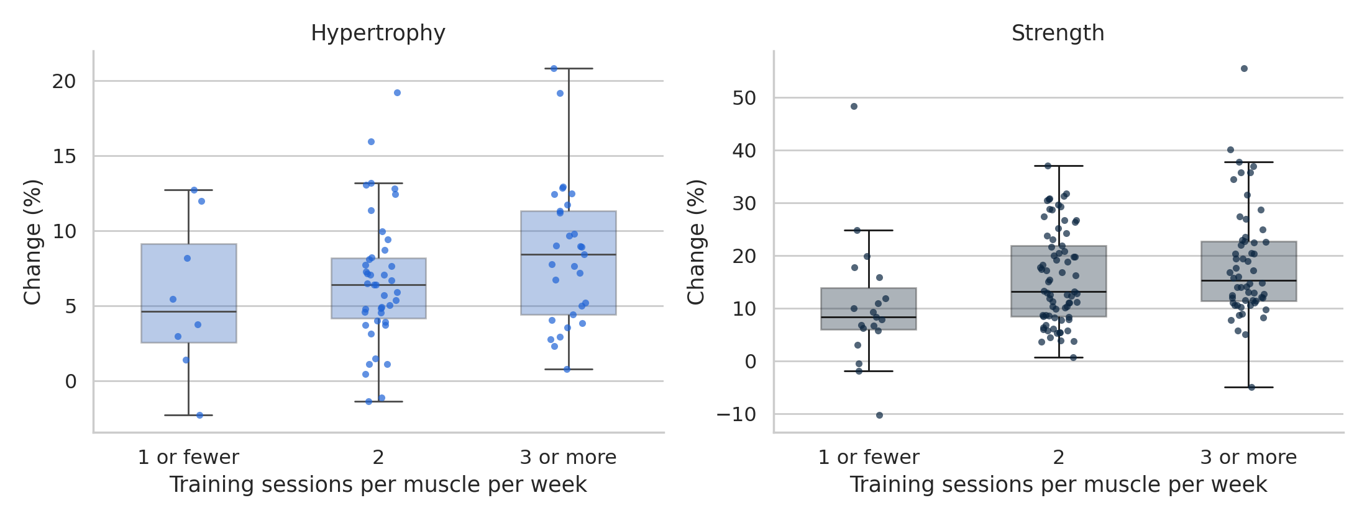
Figure 2
Change in Muscle Size and Strength by Weekly Sets
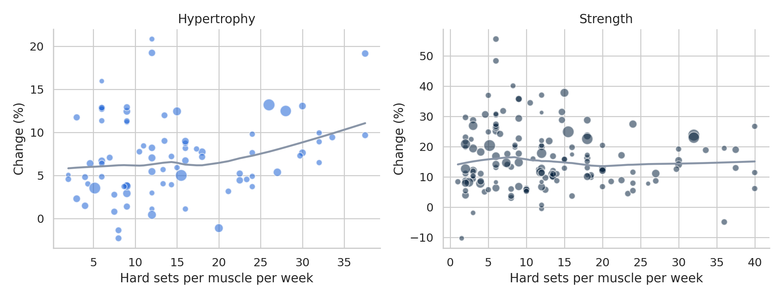
Methods
ANOVA and ANCOVA
Frequency was divided into three groups (1 or fewer, 2, and 3 or more sessions per muscle per week), and the mean gains were compared with a one-way ANOVA and Tukey's test. An ANCOVA was then performed with adjustment for weekly sets, weeks, age, percent male, and training status. Remember that the groups from the same study are not independent (like in classic ANOVA assumptions), so I use p values as descriptive, with a study-clustered test of the frequency groups.
Regression Models
Each outcome was modeled with four different models. Model 1 included frequency and covariates. Model 2 added weekly sets. Model 3 included frequency*weekly sets to answer Research Question 4. Model 4 added weekly sets squared to model diminishing returns. Covariates were weeks, age, %males, and training status. Continuous predictors were centered. Weekly sets was measured in units of 10 sets, with all groups scaled to a single set to interpret the intercept (roughly a "typical" group). Models were fit with weighted least squares with groups weighted by size. Standard errors were clustered on study because groups within a study will tend to have similar laboratory, testing, and population characteristics (see intraclass correlations, Results). A mixed model with a random intercept for study was used as a confirmatory model.
Validation and Robustness
The predictive accuracy of the models was estimated using repeated 5-fold cross-validation (30 repetitions), leaving out entire studies in sets. This prevents groups from the same study on both sides of the split, which can artificially simplify the test. Bootstrapping, resampling entire studies 2,000 times (Efron & Tibshirani, 1993), yielded confidence intervals for the models. Shapiro-Wilk, Breusch-Pagan, and the RESET test, variance inflation factors, and Cook's distance were used to verify assumptions. Model 2 was refit in 5 different ways (weighted, unweighted, a mixed model, a model with a log-ratio outcome, and a model without outliers) to see if any conclusions depend on the setup. All tests were performed in Python using the statsmodels package (Seabold & Perktold, 2010).
Results
ANOVA and ANCOVA
This analysis of hypertrophy found that the mean percentage change was 5.52% with one or less sessions, 6.63% with two sessions, and 8.42% with three or more sessions. These differences were not statistically significant, F (2, 76) = 1.88, p =.160, η2 =.047 (see Table 6). However, the analysis of strength found that the mean percentage change was 10.55% with one or less sessions, 15.75% with two sessions, and 18.27% with three or more sessions.
The difference across groups was statistically significant, F (2, 147) = 4.37, p =.014, η2 =.056.
Using Tukey's post hoc test, one between group comparison was significant: three or more sessions produced 7.7 percentage points (95% CI [1.5, 14.0]) greater change than one or less sessions, p =.011. Only eight hypertrophy groups and nineteen strength groups were used in this lowest frequency comparison.
When additional covariates were entered the hypertrophy differences were no longer statistically significant, F(2, 71) = 0.43, p =.655, partial η2 =.012. The strength trend, however, was maintained but reduced to statistical no significance, F(2, 142) = 2.86, p =.060 (study-clustered test p =.073), partial η2 =.039 (see Figure 3).

Table 6
Mean Change by Frequency Level, Before and After Adjustment
Outcome | Level | Mean (%) | Adjusted mean (%)
Hypertrophy | 1 or fewer | 5.5 | 6.8
 | 2 | 6.6 | 6.8
 | 3 or more | 8.4 | 7.8
Strength | 1 or fewer | 10.6 | 12.1
 | 2 | 15.8 | 15.5
 | 3 or more | 18.3 | 18.1

Figure 3
Adjusted Mean Change by Training Frequency
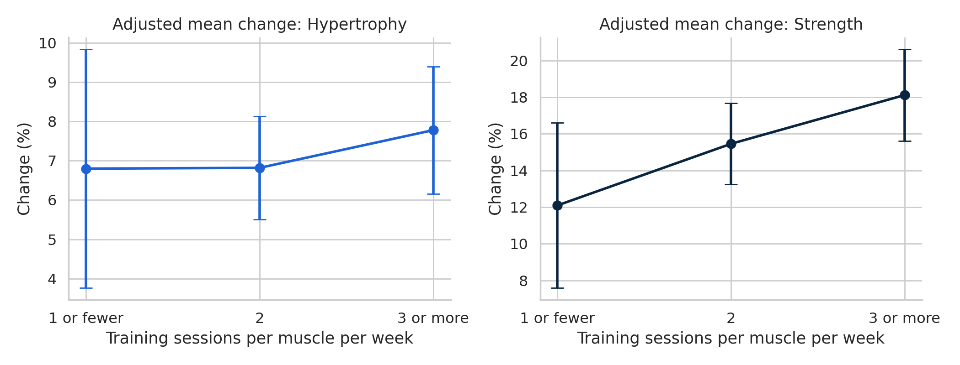
Regression
Examining hypertrophy, the regression model suggested frequency alone showed a potential advantage of 1.23% per training session per week (p =.006). When weekly sets were added into the equation, however, frequency coefficient was diminished to 0.69 (95% CI [0.15, 1.53], p=.104) and weekly sets were statistically more significant, with a 2.39 points per 10 sets advantage (95% CI [1.11, 3.68], p=.001). Additionally, the R increased from.12 to.28.
This finding indicates the potential effect of frequency found in the first model was largely due to an effect of volume. Therefore, the null hypothesis for RQ2 was rejected and that for RQ1 was not. Finally, trained groups gained 3.8 points less than untrained groups (p=.030).
On the other hand, strength showed that frequency was still a predictor after considering volume contributing 1.98 points per additional session (95% CI [0.25, 3.70], p =.025), whereas weekly sets did not have a significant effect and contributed only 0.81 points per 10 sets (95% CI [1.11, 2.73], p =.402). As such, null is not rejected for RQ3 for volume but it is for frequency (i.e. Which is not for volume). Moreover, 7.5 points was gained by untrained groups, less than trained groups and it was significant at a high level (p =.001).
Table 7
Regression Results, Model 2 (Main Effects)
Predictor | Hypertrophy b [95% CI] | p | Strength b [95% CI] | p
Frequency (per session) | 0.69 [−0.15, 1.53] | .104 | 1.98 [0.25, 3.70] | .025
Weekly sets (per 10 sets) | 2.39 [1.11, 3.68] | .001 | 0.81 [−1.11, 2.73] | .402
Weeks (per week) | −0.17 [−0.35, 0.01] | .062 | −0.02 [−0.41, 0.37] | .914
Age (per year) | −0.27 [−0.67, 0.14] | .185 | −0.20 [−0.58, 0.17] | .285
Percent male (0 to 1) | −2.62 [−13.20, 7.97] | .619 | −3.02 [−11.84, 5.80] | .497
Trained (vs. untrained) | −3.84 [−7.28, −0.39] | .030 | −7.55 [−11.83, −3.27] | .001
Intercept | 9.01 |  | 20.02
R² (adjusted R²) | .283 (.224) |  | .205 (.171)
The Interaction
RQ4-Interaction analysis The interaction was trivial for hypertrophy (0.01, p =.986) and the squared sets term in Model 4 was not significant. For strength, it was negative (-1.60, 95% CI [-3.11,- 0.08], p =.040). The effect of an additional session per week was 3.7 points at low volume (about 3.5 sets per week), 2.2 points at mean volume (13 sets), and 0.7 points at high volume (22 sets; see Figure 5). This indicates that when volume is low, there is a tendency for session frequency to provide a benefit, although this is not certain: the study-level bootstrap interval ([-3.36, 0.02]) includes zero, and four hypotheses were tested without correction.

Figure 4
Predicted Change Across Weekly Sets (Model 4)
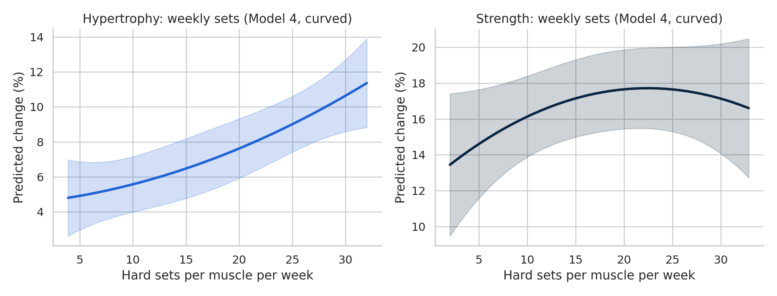
Figure 5
Frequency Effect at Low, Average, and High Weekly Volume (Model 3)
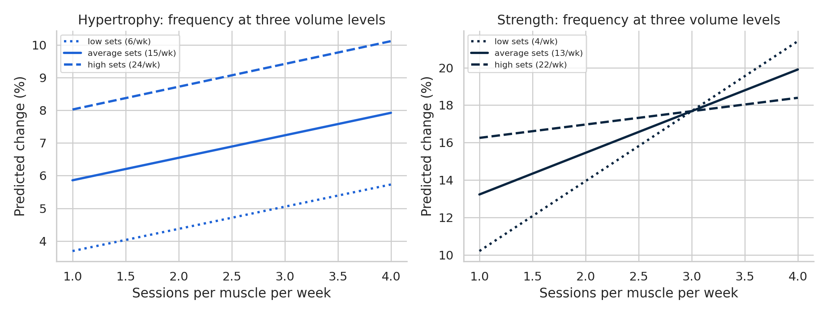
Model Comparison and Validation
Comparing models and model validation. Clearly increasing the number of terms adds to the fit to the data that was available, but the validation was done on held-out studies (Table 8). On hypertrophy, no model was better than estimation of the mean of all studies (cross-validated R=-.045 for the mean alone). For hypertrophy, adding weekly sets was particularly helpful in model 2 (R=-.150, RMSE=4.93 points vs-.339 sets alone and-.431 covariates alone), but in strength, weekly sets simply added something of value to frequency (for.051 of Model 1 or.050 of Model 3 versus. 029 covariates alone and-.037 the average). I report the hypertrophy Model 2, main effects by Model 2, and RQ4 in strength by Model 3. These models seem to describe relationships within the studies well, but do not seem to be especially predictive of new studies.

Table 8
Training Fit and Cross-Validated Performance
Outcome | Model | R² | CV R² | CV RMSE
Hypertrophy | Average only | — | −.045 | 4.71
 | Covariates only | — | −.431 | 5.50
 | Model 1 | .124 | −.339 | 5.32
 | Model 2 | .283 | −.150 | 4.93
 | Model 3 | .283 | −.173 | 4.98
 | Model 4 | .290 | −.186 | 5.01
Strength | Average only | — | −.037 | 10.34
 | Covariates only | — | .029 | 10.00
 | Model 1 | .200 | .051 | 9.89
 | Model 2 | .205 | .031 | 9.99
 | Model 3 | .220 | .050 | 9.90
 | Model 4 | .216 | .019 | 10.05

The bootstrap data at the study level was in accordance with the clustered regression output: hypertrophy - 95% CI= [0.23, 1.48] for frequency, [0.71, 3.66] for weekly sets, strength - 95% CI= [0.43, 3.81] for frequency, [1.36, 2.65] for weekly sets.Assumption Checks and Robustness
Tests of assumptions showed no perfect normal distribution (Shapiro-Wilk p =.006 and.003) with some outlying high gains (Figure 7), so the use of clustered standard errors and the study-level bootstrap is justified over the use of normal-theory p-values. The variance was about equal (Breusch- Pagan p =.052 and.065), the model form was satisfactory (RESET p =.873 and.742), collinearity low (largest VIF 1.84 and 1.45), and no group was overly influential (largest Cook's d 0.006 and 0.002). Most of the variance was between studies (intraclass correlation.55 for hypertrophy and.81 for strength) so assuming the group was independent would have been optimistic.Results were consistent in the five different configurations (Table 9, Figure 6). Weekly sets was significant and positive for hypertrophy in each of the five configurations, but frequency was not significant once volume was added into the model. For strength, frequency was significant and positive in each of the five configurations, but weekly sets was not.

Table 9
Model 2 Coefficients Under Five Setups
Outcome | Version | Frequency b (p) | Weekly sets b (p)
Hypertrophy | Main (WLS, clustered) | 0.69 (.104) | 2.39 (.001)
 | Unweighted (OLS, clustered) | 0.78 (.105) | 2.24 (.002)
 | Mixed model (study intercept) | 0.11 (.792) | 2.97 (< .001)
 | Log-ratio outcome | 0.64 (.101) | 2.24 (< .001)
 | No outliers | 0.44 (.180) | 2.27 (< .001)
Strength | Main (WLS, clustered) | 1.98 (.025) | 0.81 (.402)
 | Unweighted (OLS, clustered) | 2.08 (.017) | 0.23 (.832)
 | Mixed model (study intercept) | 1.19 (.020) | 1.14 (.124)
 | Log-ratio outcome | 1.68 (.022) | 0.75 (.362)
 | No outliers | 2.09 (.020) | 1.14 (.228)

Figure 6
Frequency and Volume Coefficients Under Five Setups
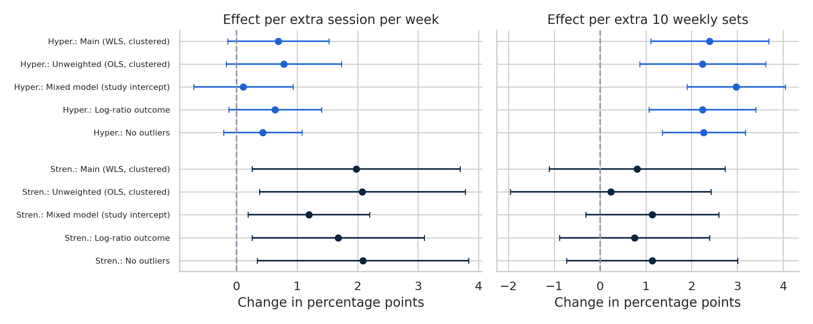
Figure 7
Residual Checks for Model 2
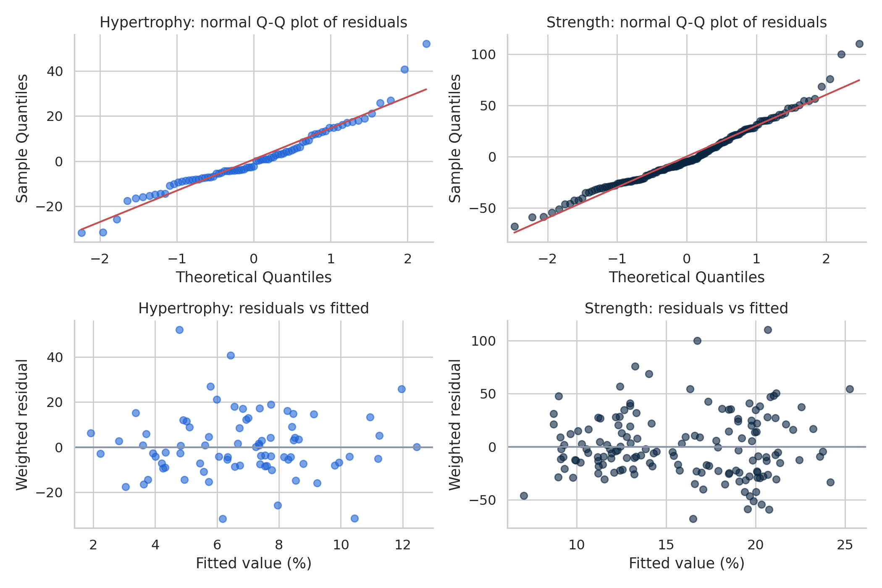

Discussion
What We Found
The authors identified two trends: 1) the more weekly sets a group did, the greater the muscle size they gained, up to a level of + 2.4 points per 10 weekly sets, when controlling for frequency, and 2) the more frequently a group trained a given muscle, the greater the increase in their strength, up to a level of + 2.0 points per weekly session, when controlling for volume. In the muscle-size models, frequency increased muscle size when volume was not taken into account, but this effect essentially disappeared when volume was taken into account. In the strength models, weekly session frequency was most advantageous at lower weekly volume, but this is seen as a preliminary lead-in and as something to be investigated further.
These directions are consistent with the meta-regression results that these data are taken from (Pelland et al., 2026) showing volume is primarily important for muscle size but frequency remains significant for strength. These results lend further support to the hypothesis of Schoenfeld et al. (2016) that the apparent advantage of frequency for muscle size may be largely due to more volume. It should be clarified that, in outcome scale, model parsimony, and weighting of the models, our models differ from Pelland et al.'s thus the direction of agreement is as far as we can confidently claim.
Limitations
All data is group averages, so these trends may not apply intra-individually. The study designs predetermined volume and frequency so causality cannot be inferred, as a high-volume study may be due to other factors. There are very few low-frequency/volume groups (n=8 hypertrophy and 19 strength groups trained a muscle once per week or less), so estimates on the lower frequency and volume end is not a good representation of what happens in a low-protein diet.
Strength tests and measures of muscle size varied between the studies, so percent change only gives an approximation of how similar tests and measures may compare (e.g.
You cannot compare a wrist curl to a leg extension). Group size weighting rather than variance of each effect in the analysis means that the analysis is not comparable to a meta-analysis and published articles may be missing small or null effects that have no effect on the pattern. Cross validation showed that these models predict new studies poorly, so these estimates are useful for describing how two variables relate, but not how they will predict outcomes in new studies. The dataset does not have a protein variable so we can't analyze effects of protein intake.

Conclusion
The referenced data indicates a consistent trend of greater weekly volume corresponding to larger muscle gains, and greater weekly frequency being associated with strength gains-where a consistent trend was seen for all the models fitted. However, it was found that most of the variation is between studies, that the models do a poor job in predicting future study results, and that the data describe associations, not causality. A reasonable next step is to analyze the same data, but at the individual level, and with food records used to estimate protein intake.

References
Efron, B., & Tibshirani, R. J. (1993). An introduction to the bootstrap. Chapman & Hall.
Morton, R. W., Murphy, K. T., McKellar, S. R., Schoenfeld, B. J., Henselmans, M., Helms, E., Aragon, A. A., Devries, M. C., Banfield, L., Krieger, J. W., & Phillips, S. M. (2018). A systematic review, meta-analysis and meta-regression of the effect of protein supplementation on resistance training-induced gains in muscle mass and strength in healthy adults. British Journal of Sports Medicine, 52(6), 376–384. https://doi.org/10.1136/bjsports-2017-097608
Pelland, J. C., Remmert, J. F., Robinson, Z. P., Hinson, S. R., & Zourdos, M. C. (2025). Extracted data, analysis scripts, and supplementary materials for “The resistance training dose response” [Data set]. Open Science Framework. https://osf.io/6z3xu
Pelland, J. C., Remmert, J. F., Robinson, Z. P., Hinson, S. R., & Zourdos, M. C. (2026). The resistance training dose response: Meta-regressions exploring the effects of weekly volume and frequency on muscle hypertrophy and strength gains. Sports Medicine, 56(2), 481–505. https://doi.org/10.1007/s40279-025-02344-w
Schoenfeld, B. J., Ogborn, D., & Krieger, J. W. (2016). Effects of resistance training frequency on measures of muscle hypertrophy: A systematic review and meta-analysis. Sports Medicine, 46(11), 1689–1697. https://doi.org/10.1007/s40279-016-0543-8
Seabold, S., & Perktold, J. (2010). Statsmodels: Econometric and statistical modeling with Python. In S. van der Walt & J. Millman (Eds.), Proceedings of the 9th Python in Science Conference (pp. 92–96). https://doi.org/10.25080/Majora-92bf1922-011
Tagawa, R., Watanabe, D., Ito, K., Ueda, K., Nakayama, K., Sanbongi, C., & Miyachi, M. (2021). Dose–response relationship between protein intake and muscle mass increase: A systematic review and meta-analysis of randomized controlled trials. Nutrition Reviews, 79(1), 66–75. https://doi.org/10.1093/nutrit/nuaa104

